**POLS0010 Term 2 Assessment | Plan**

**RELEASE**

**PART 1 WEDNESDAY 20TH FEBRUARY 2019 60%, WEEKS 11-16 60 MARKS**

**1,800 WORDS (PART A : 1000 WORDS / PART B : 800 WORDS)**

**PART 2 WEDNESDAY 20TH MARCH 2019 40%, WEEKS 17-20 40 MARKS**

**1,200 WORDS (PART C: 1200 WORDS)**

**DEADLINE**

ESSAY 14:00, TUESDAY 23RD APRIL 2019, VIA TURNITIN 3,000 WORDS

**TIMELINE**

QUESTION B CODED FULLY, WELL-STRUCTURED (PERFECTED, NEAT)

QUESTION B REPORT FULLY DRAFTED (MAX 900 WORDS)

PART A (QUESTIONS A AND B) FULLY COMPLETED, REFINED, CHECKED

[PART A COMPLETE (CODE PERFECTED, REPORT AT 1,800 WORDS EXACTLY]

**TASK**

* USE DATASETS TO ANSWER A RESEARCH QUESTION
* PRESENT FINDINGS IN THE FORM OF A SHORT, WRITTEN REPORT
* EXPECTED TO INCLUDE TABLES AND FIGURES

***DETAILS***

* ASSUME THE READER UNDERSTANDS THE TECHNIQUES YOU’RE USING
* USE CONTINUOUS PROSE
* DIVIDE THE WORD COUNT BETWEEN PARTS 1 AND 2 + WITHIN EACH PART (60%/40%)
* 3,000-WORDS IS A LIMIT, NOT A TARGET – BE SUCCINCT
* R-CODE AND WORDS IN TABLES DO NOT COUNT FOR THE WORD LIMIT

**QUESTION A**

1. ~~Explain which types of people are most supportive of gun control~~
2. ~~Present findings: explain how much each characteristic matters in explaining support for gun control~~
3. ~~Explain who the groups~~ **~~most likely~~** ~~to support gun controls are~~

**QUESTION B**

~~LOOK DIRECTLY AT THE RANDOM EFFECTS AND MARGINAL EFFECTS TO FIND INCONSISTENCIES: DO THE PREDICTORS HAVE THE SAME EFFECT AT THE UPPER (MFX) LEVEL AS THEY DO ON THE CONSTITUENCY LEVEL?~~

1. **~~PRESENT THE MODEL RESULTS AND INTERPRET HOW THE VARIABLES AFFECT VOTING TO LEAVE THE EU~~**
2. **~~EXPLAIN WHY PEOPLE OVERALL VOTED TO LEAVE THE EU USING MY RESULTS~~**
3. **~~DESCRIBE/EXPLAIN HOW SUPPORT FOR LEAVING DIFFERED ACROSS CONSTITUENCIES~~**

* ~~DO CIPPs FOR THE MULTILEVEL MODEL?~~
* ~~PLOT RANDOM EFFECTS? PLOT FIXED EFFECTS? ACCOUNT FOR BOTH FIXED AND RANDOM EFFECTS~~
* ~~CREATE COMPLEX ANALYSIS OF HOW MUCH FACTORS MATTER BASED ON DEMOGRAPHICS~~
* ~~ENSURE POSTRATIFIED RESULTS ARE USED: DEMOGRAPHICS AND CONSTITUENCY DIFFERENCES~~

**QUESTION C**

~~BRIEF REPORT WHICH DESCRIBES THE TWEETS + RECOMMENDS A FUTURE CLASSIFICATION METHODS~~

1. ~~DESCRIBE THE TWEETS:~~
2. ~~WHAT WORDS ARE ASSOCIATED WITH NEGATIVE OR POSITIVE SENTIMENT?~~
3. ~~HOW DOES WORD USEAGE DIFFER ACROSS DIFFERENT AIRLINES?~~
4. ~~BUILD A SHORT DICTIONARY OF NEGATIVE AND POSITIVE WORDS DESCRIBING AIRLINES~~
5. ~~USE THE DICTIONARY TO CLASSIFY TWEETS AS NEGATIVE OR POSITIVE~~
6. ~~USE A MACHINE LEARNING METHOD TO CLASSIFY TWEETS INTO NEGATIVE AND POSITIVE~~
7. ~~COMPARE THE PERFORMANCE FROM MY CLASSIFIERS FROM 2 TO 3~~
8. ~~USE ANALYSIS TO DECIDE WHICH ONE IS THE BETTER CLASSIFIER FOR THE COMPANY TO USE IN FUTURE~~

**SKILLS TESTED**

***ANALYSIS***

1. KNOWLEDGE AND UNDERSTANDING OF THE COURSE MATERIAL
2. GENERAL SKILLS
3. DISTINCTION BETWEEN PREDICTION AND HYPOTHESIS TESTING
4. SIMULATION INFERENCE
5. TRANSFORMATION OF REGRESSION OUTPUT INTO USEFUL QUANTITIES
6. LOGIT MODELS
7. MODEL SELECTION: BEST SET OF VARIABLES FOR PREDICTION
8. CHANGES IN PREDICTED PROBABILITIESAND AVERAGE MARGINAL EFFECTS
9. HYPOTHESIS TESTING VIA SIMULATION
10. PANEL AND MULTILEVEL MODELS
11. RANDOM EFFECTS: VARYING INTERCEPTS AND SLOPES
12. SOLVING THE ECOLOGICAL FALLACY PROBLEM
13. INTERPRETATION, PREDICTION, HYPOTHESIS TESTING: FIXED AND RANDOM EFFECTS
14. WRITING UP AND PRESENTING STATISTICAL RESULTS
15. APPLY THE TECHNIQUES IN R
16. USE TABLES, VISUALISATIONS, TO SHOW YOUR RESULTS
17. INTERPRET YOUR RESULTS CLEARLY, SUCCINCTLY AND PRECISELY
18. USE RESULTS TO TEST CLAIMS AND UNDERSTAND SOCIAL SCIENCE QUESTIONS

***PRESENTATION***

1. *R CODE*

*R Code which is messy and difficult to read makes it harder to award marks.*

*“CODE FOR TABLE 1” “CODE FOR FIGURE 1” “CODE FOR Q1.1” – EXTENSIVE COMMENTING*

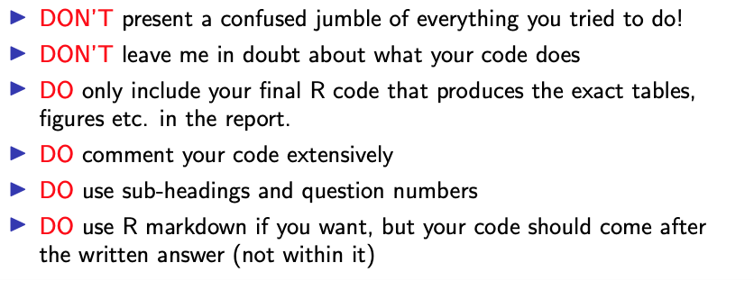

*INCLUDE R CODE AS AN R-MARKDOWN (PDF) AT THE END OF THE DOCUMENT ONLY – NO CODE IN THE DOCUMENT/WRITE-UP ITSELF, AT ALL.*

1. *TABLES AND FIGURES*

*Good tables and figures are vital. Marks are awarded for presentation. They must be able to stand independently and be self-explanatory with NO raw variable names, and appropriate annotations or comments (and make these align with the code used to create them).*

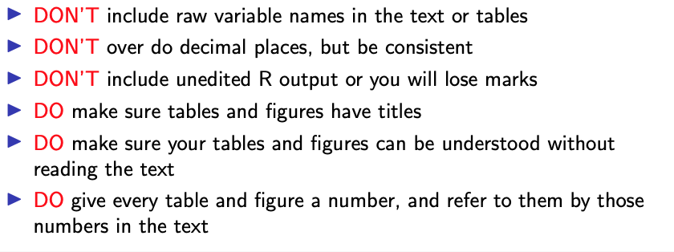

1. *TRANSFORMING THE REGRESSION OUTPUT*

*The core feature of all models is that regression outputs alone are not meaningful.*

1. LOGIT MODELS
2. NEVER PRESENT JUST THE COEFFICIENTS
3. TRANSLATE THEM INTO AVERAGE MARGINAL EFFECTS, ODDS RATIOS, CHANGES IN PREDICTED PROBABILITIES
4. CHOOSE APPROPRIATE QUANTITIES FOR THE TASK AT HAND
5. FOR MULTILEVEL MODELS
6. MUST DISTINGUISH BETWEEN:
7. FIXED COEFFICIENTS
8. COEFFICIENTS THAT VARY ACROSS LEVEL-2 UNITS
9. EXACTLY WHAT YOU PRESENT CAN DEPEND ON THE QUESTION: ARE YOU INTERESTED IN PARTICULAR LEVEL-2 UNITS, OR THE GENERAL IMPACT TO THE INDEPENDENT VARIABLES? (OFTEN BOTH)

***WRITING***

1. NEVER LEAVE THE READER IN ANY DOUBT ABOUT HOW YOU DID THE ANALYSIS

* BY READING PROSE, NOT CODE, THE READER SHOULD BE ABLE TO REPRODUCE THE WORK

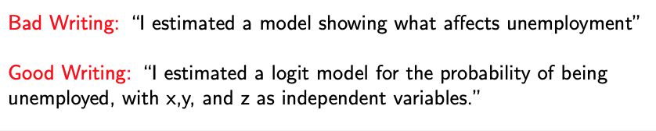

1. BE PRECISE WITH TEST RESULTS

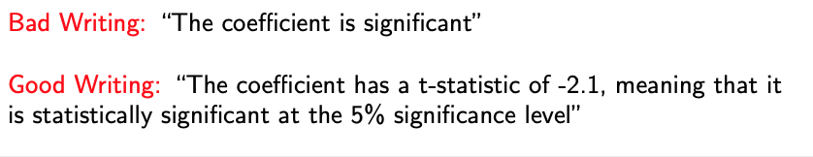

* PRECISION: HOW BIG IS THE EFFECT? GIVE A SPECIFIC EXAMPLE TO ILLUSTRATE
* RELATE THE SIZE OF THE COEFFICIENT TO THE SCALE OF THE OUTCOME VARIABLE
* MAKE THE RESULTS COMPELLING AND MEANINGFUL

